**Student – To – Do – List**

**Briones Miles  
Briones Iarian Dave  
Joemer Calunsag**

The Student To-Do List is a well-organized application designed specifically to address the unique needs of students. By providing a structured platform to manage tasks, assignments, deadlines, and even personal goals, it empowers students to stay on top of their workload. With features tailored to streamline academic life, this application not only helps in prioritizing tasks but also in breaking down larger projects into manageable steps. By doing so, it reduces the overwhelm that often accompanies a busy schedule, allowing students to focus more on their studies and less on the stress of trying to remember everything.

**Calendar**

This is the calendar where you can set your task.

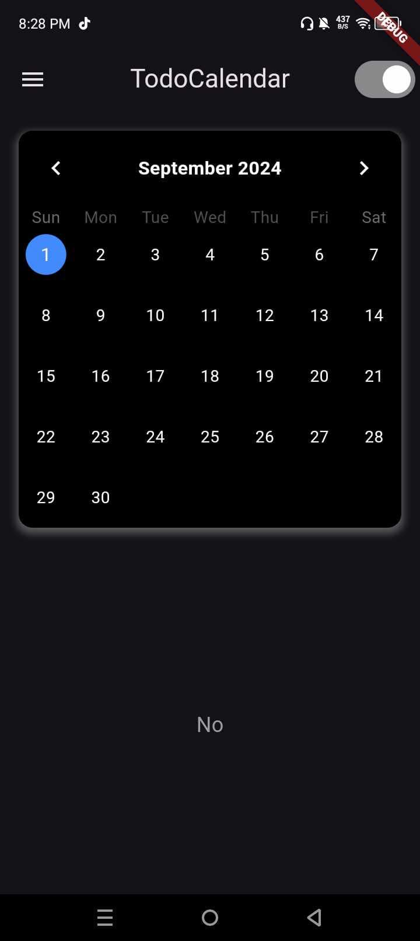

**Real Time**

It also have a real time because its connected on real time and real date.

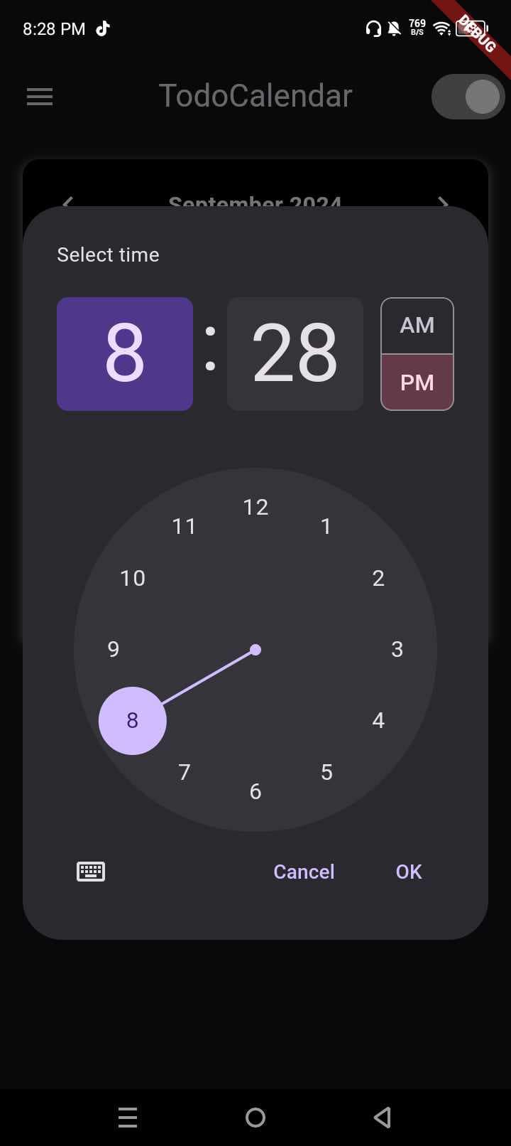

**Set task**

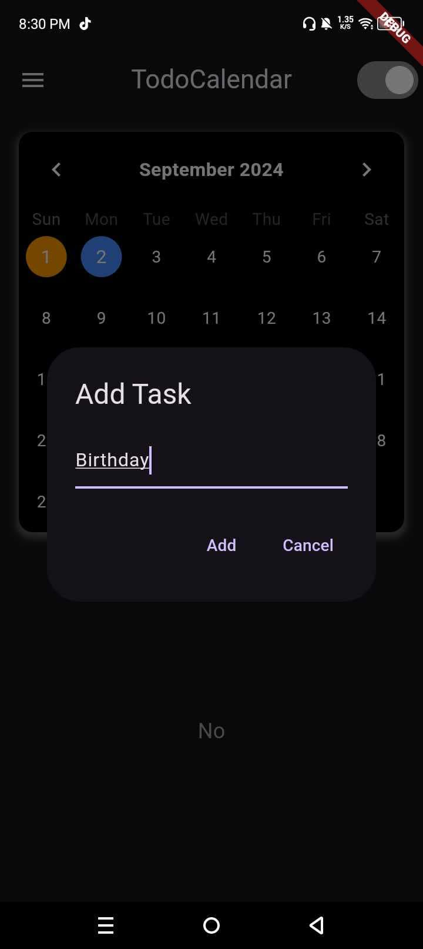This is where the students will set the task.

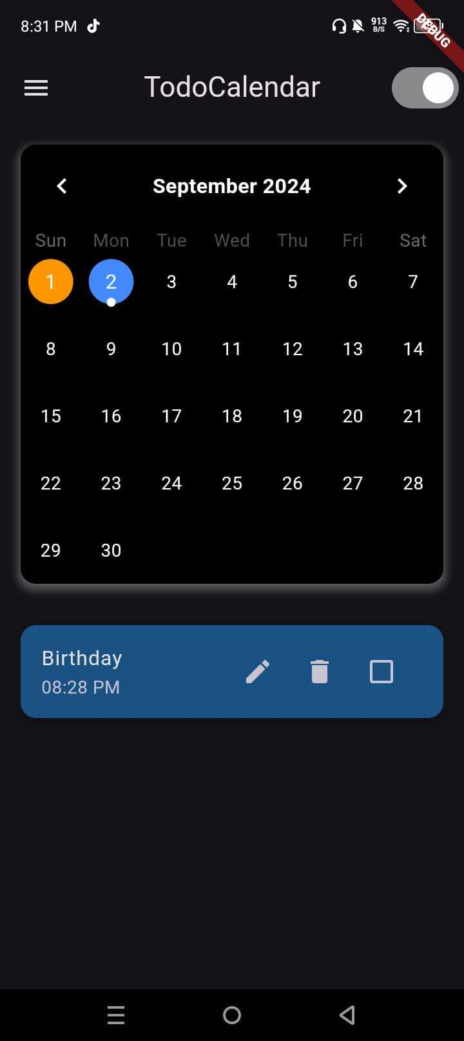after setting your task you will see below the task that you set and also theirs an edit button beside the delete button you can use it to change the color of the task.

It also has a features like night mode and light mode. 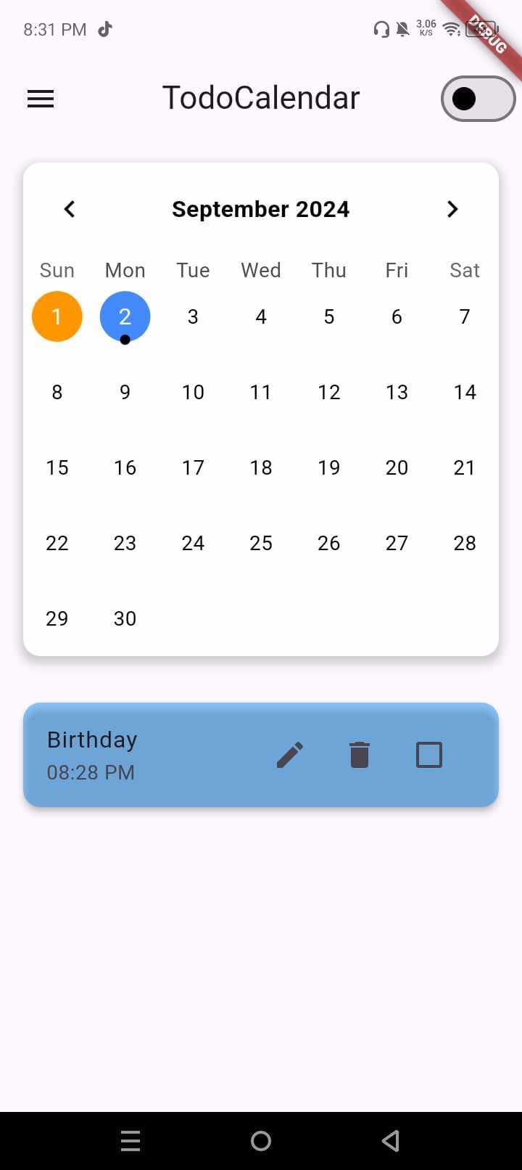

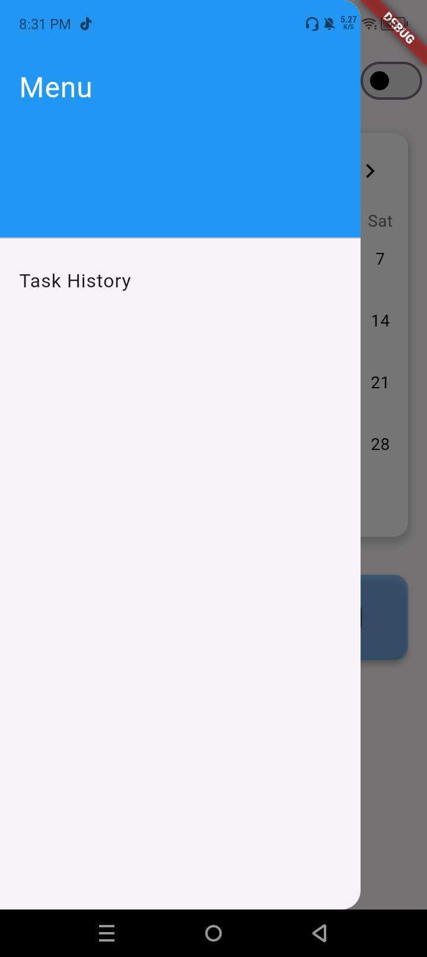In Menu you will see their the task history where you will see all your past task.

